INTELLIGENT ADMISSION:THE FUTURE OF UNIVERSITY DECISION MAKING WITH MACHINE LEARNING

TEAM LEADER

LOKESHWARI V

TEAM MEMBERS

LAKSHMI G

LIVETHA U

MONIKA B

|  |  |  |
| --- | --- | --- |
| 1. | INTRODUCTION |  |
|  | 1.1 Overview |  |
|  | 1.2 Purpose |  |
| 2. | Problem Definition & Design Thinking |  |
|  | 2.1 Empathy Map |  |
|  | 2.2 Ideation & Brainstorming Map |  |
| 3. | RESULT |  |
| 4. | ADVANTAGES & DISADVANTAGES |  |
| 5. | APPLICATIONS |  |
| 6. | CONCLUSION |  |
| 7. | FUTURE SCOPE |  |
| 8. | APPENDIX |  |
|  | A. Source Code |  |

**INTRODUCTION**

* 1. Overview

University admission is the process by which students are selected to attend a college or university. The process typically involves several steps, including submitting an application, taking entrance exams, and participating in interviews or other evaluations. Students are often worried about their chances of admission in University. the university admission ocess for students can be demanding, but by being well-informed, prepared, and organized, students can increase their chances of being admitted to the university of their choice.

The aim of this project is to help students in short listing universities with their profiles. Machine learning algorithms are then used to train a model on this data, which can be used to predict the chances of future applicants being admitted. With this project, students can make more informed decisions about which universities to apply to, and universities can make more efficient use of their resources by focusing on the most promising applicants.The predicted output gives them a fair idea about their admission chances in a particular university. This analysis should also help students who are currently preparing or will be preparing to get a better idea.

* 1. Purpose:

This article was an early beta test. See all-new collaborative articles about Machine Learning to get expert insights and join the conversation. Machine learning has become an increasingly popular tool in recent years, given its ability to automatically detect patterns in data and make predictions about future events. This can be extremely useful for making decisions in a wide range of domains, from financial trading to medical diagnoses. Here are some ways in which machine learning can be used to improve decision making.

**Problem Definition & Design Thinking**

2.1 Empathy Map:

An empathy map is a collaborative visualization used to articulate what we know about a particular type of user. It externalizes knowledge about users in order to 1) create a shared understanding of user needs, and 2) aid in decision making.

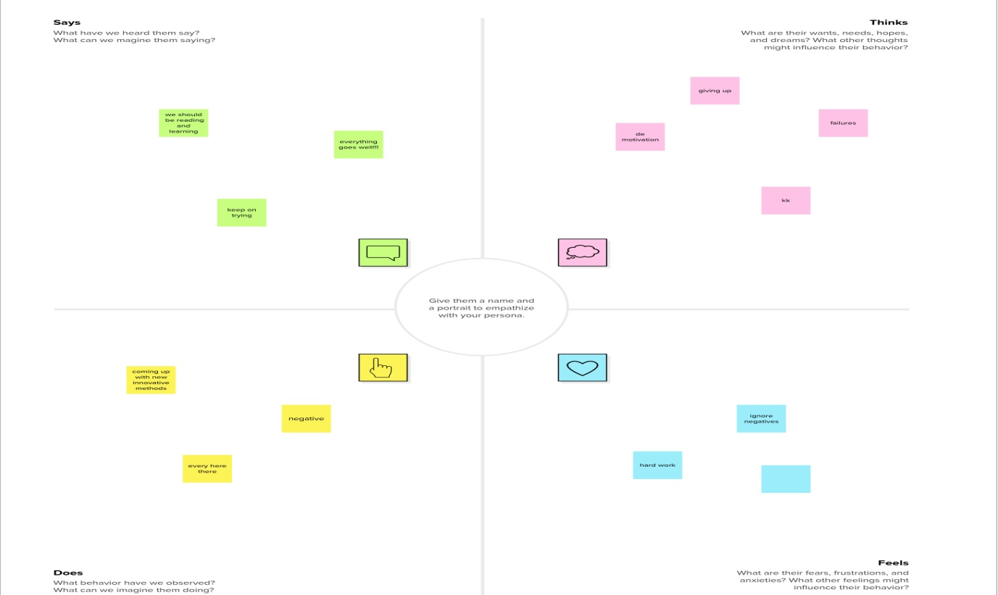

2.2 Ideation & Brainstorming Map:

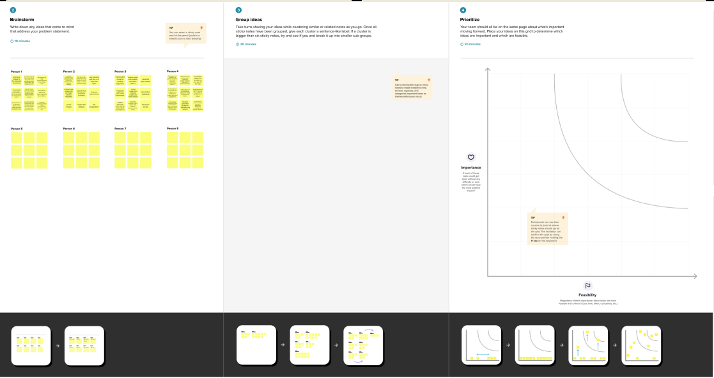

3. RESULT

Through this educational model, the students can guide their own learning. They can have their own pace and can make decisions about what to learn and how to learn. They can choose the subjects they are interested in, the teacher they want to learn from and what curriculum, standards and pattern they want to follow

**UNIVERSITY ADMISSION PREDICTION**

Top of Form

Enter GRE SCORE:   
Enter TOEFL SCORE:   
Enter UNIVERSITY RANKING:   
Enter SOP:   
Enter LOR:   
Enter CGPA:   
Enter Research:   
Predict

Bottom of Form

**UNIVERSITY ADMISSION PREDICTION**

Top of Form

Enter GRE SCORE:   
Enter TOEFL SCORE:   
Enter UNIVERSITY RANKING:   
Enter SOP:   
Enter LOR:   
Enter CGPA:   
Enter Research:   
Predict

Bottom of Form

**You dont have a chance of admission**

4. ADVANTAGES & DISADVANTAGES

ADVANTAGE:

* Quick Identification of Trends and Patterns
* It is automatic and does not require human interference
* Continual Development
* Adoption by Multi-industries

Quick Identification of Trends and Patterns:

Machine learning can evaluate massive amounts of data and find precise patterns and trends that people might overlook. For Instance, e-commerce sites like Amazon are enabled with information on their customers' purchasing patterns and history which helps in recommending them the appropriate goods, discounts, and reminders. It makes use of the information to present consumers with pertinent advertisements

A machine can gain knowledge more as it accumulates data, and as it accumulates data, it also learns patterns and trends. Consider how social networking sites like Facebook or Instagram function. The data of the users' interests and browsing history are recorded and understood through patterns that are then displayed to them to maintain their interest in the same app. Machine learning assists in recognizing trends and patterns in this way.

It is automatic and does not require human interference:

Machine learning equips computers with the ability to carry out the entire data interpretation and analysis process on its own. There is no need for you to supervise your project at every stage. Take for example how anti-virus programs work. They learn to filter new threats upon identification.

For the prediction or interpretation of the results, no human interaction is necessary. The entire machine learning process begins with machine learning and anticipating the algorithm or program that will produce the best outcome. Another example is Google Home, which recognizes voice commands and then determines the desired outcome for the user.

Continual Development:

With experience and more operations, Machine learning gain effectiveness and accuracy. They can consequently make wiser selections. Take the example of creating a weather forecast model. With the expansion of your data, the predictions become more accurate and the algorithm speeds up in producing the predictions.

Handles data with several dimensions and variants

A machine learning algorithm is capable of managing multivariate and multidimensional data even in the most uncertain contexts and dynamic situations. It can manage a range of facts even in a hazy and unpredictable environment. It is both multifaceted and multitasking

Adoption by Multi-industries:

Machine learning is employed in a variety of industries, including education, medicine, engineering, and other areas of daily life. ranging from a very modest application to very large and complex structured machines that aid in data analysis and prediction. It not only turns into a healthcare provider but also offers prospective clients more individualized services.

DISADVANTAGE:

* Data Acquisition
* Time and Resources Intensive
* Chances of faulty Interpretation of data
* Requirement of more Space

Data Acquisition:

Machine learning mandates the need for large, unbiased, comprehensive, and high-quality data sets for training. They are sometimes required to stand by for new data generation. For better forecasting or decision-making with Machine Learning, a computer needs to be fed with more data since the more data it receives, the more accurate and effective it becomes. But occasionally, it might not be achievable. Additionally, the information must be accurate and neutral. Data requirements can be challenging at times.

Time and Resources Intensive:

For machine learning (ML) to be effective, the algorithms must have enough time to mature and learn enough to achieve their goals with a high degree of accuracy and relevance. This could result in you needing more processing power from your machine. The machine may occasionally take a long time to learn because efficacy and efficiency can only be attained via experience, which again takes time. In addition, it is challenged by the need for more resources to run, for instance more computers.

Chances of Faulty Interpretation of data:

The capacity to correctly comprehend the information produced by the algorithms presents one of the significant disadvantages of machine learning. Although autonomous, machine learning is prone to mistakes. Consider training an algorithm with data sets that are too tiny to be inclusive. You obtain biased predictions from a biased training set in the end. This results in customers seeing irrelevant advertisements. Such flaws in ML can start a cascade of mistakes that may be

undiscovered for a very long time. Moreover, it takes time to identify problems and even longer to find remedies. Sometimes data that is error-free can nonetheless be interpreted incorrectly by a machine because the data it was given may not have met all of its requirements.

Requirement of More Space:

More storage capacity is needed because more data is needed for interpretation, which is one of the biggest disadvantages of machine learning. It takes a lot of storage space to handle or keep data for further decision-making because more data means the computer has more information or material to learn from.

5. APPLICATIONS:

1.Social Media Features:

Social media platforms use machine learning algorithms and approaches to create some attractive and excellent features. For instance, Facebook notices and records your activities, chats, likes, and comments, and the time you spend on specific kinds of posts. Machine learning learns from your own experience and makes friends and page suggestions for your profile.

2. Product Recommendations:

Product recommendation is one of the most popular and known applications of machine learning. Product recommendation is one of the stark features of almost every e-commerce website today, which is an advanced application of machine learning techniques. Using machine learning and AI, websites track your behavior based on your previous purchases, searching patterns, and cart history, and then make product recommendations.

3. Image Recognition:

Image recognition, which is an approach for cataloging and detecting a feature or an object in the digital image, is one of the most significant and notable machine learning and AI techniques. This technique is being adopted for further analysis, such as pattern recognition, face detection, and face recognition.

4. Sentiment Analysis:

Sentiment analysis is one of the most necessary applications of machine learning. Sentiment analysis is a real-time machine learning application that determines the emotion or opinion of the speaker or the writer. For instance, if someone has written a review or email (or any form of a document), a sentiment analyzer will instantly find out the actual thought and tone of the text. This sentiment analysis application can be used to analyze a review based website, decision-making applications, etc.

5. Automating Employee Access Control:

Organizations are actively implementing machine learning algorithms to determine the level of access employees would need in various areas, depending on their job profiles. This is one of the coolest applications of machine learning

6. Marine Wildlife Preservation:

Machine learning algorithms are used to develop behavior models for endangered cetaceans and other marine species, helping scientists regulate and monitor their populations.

7. Regulating Healthcare Efficiency and Medical Services:

Significant healthcare sectors are actively looking at using machine learning algorithms to manage better. They predict the waiting times of patients in the emergency waiting rooms across various departments of hospitals. The models use vital factors that help define the algorithm, details of staff at various times of day, records of patients, and complete logs of department chats and the layout of emergency rooms. Machine learning algorithms also come to play when detecting

a disease, therapy planning, and prediction of the disease situation. This is one of the most necessary machine learning applications.

8. Predict Potential Heart Failure:

An algorithm designed to scan a doctor’s free-form e-notes and identify patterns in a patient’s cardiovascular history is making waves in medicine. Instead of a physician digging through multiple health records to arrive at a sound diagnosis, redundancy is now reduced with computers making an analysis based on available information

9. Banking Domain:

Banks are now using the latest advanced technology machine learning has to offer to help prevent fraud and protect accounts from hackers. The algorithms determine what factors to consider to create a filter to keep harm at bay. Various sites that are unauthentic will be automatically filtered out and restricted from initiating transactions.

10. Language Translation:

One of the most common machine learning applications is language translation. Machine learning plays a significant role in the translation of one language to another. We are amazed at how websites can translate from one language to another effortlessly and give contextual meaning as well. The technology behind the translation tool is called ‘machine translation.’ It has enabled people to interact with others from all around the world; without it, life would not be as easy as it is now. It has provided confidence to travelers and business associates to safely venture into foreign lands with the conviction that language will no longer be a barrier.

6. CONCLUSION:

In conclusion,the Intelligent Admission: the future of university decision making with Machine Leraning has shown that the application of machine learning algorithm can show the in Intelligent admission for the student in university

7. FUTURE SCOPE:

Machine learning uses statistical patterns to make accurate predictions. The technology is also helpful in document analysis, fraud detection, KYC processing, high-frequency trading, etc. It is the future scope of machine learning which is scouring the banking sector.

8. APPENDIX

Source code

import pandas as pd

import numpy as np

import pickle

import matplotlib.pyplot as plt

%matplotlib inline

import seaborn as sns

import sklearn

from sklearn.preprocessing import LabelEncoder, OneHotEncoder

from sklearn.linear_model import LogisticRegression

from sklearn.tree import DecisionTreeClassifier

from sklearn.ensemble import RandomForestClassifier

from sklearn.neighbors import KNeighborsClassifier

from sklearn.svm import SVC

from sklearn.model_selection import RandomizedSearchCV

from sklearn.model_selection import train_test_split

from sklearn.preprocessing import StandardScaler

from sklearn.metrics import accuracy_score, classification_report, confusion_matrix,f1_score

data = pd.read_csv('/content/Admission_Predict.csv')

data.head()

data.drop(["Serial No."],axis=1,inplace=True)

data.head()

data.describe()

data.info()

data.isnull().any()

data.corr()

sns.heatmap(data.corr(),annot=True,cmap="RdYlGn")

sns.pairplot(data=data,hue='Research',markers=["^","v"],palette='inferno')

sns.scatterplot(x='University Rating',y='CGPA',data=data,color='Red', s=100)

category = ['GRE Score','TOEFL Score','University Rating','SOP','CGPA','Research','Chance of Admit ']

color = ['yellowgreen','gold','lightskyblue','pink','purple','orange','red']

start = True

for i in np.arange(3):

  fig = plt.figure(figsize=(14,7))

  plt.subplot2grid((3,2),(i,0))

 # data[category[2*i]].hist(color=color[2*i],bins=10)

  data[category[2*i]].hist(color=color[2*i],bins=10)

  plt.title(category[2*i])

  plt.subplot2grid((3,2),(i,1))

  data[category[2*i+1]].hist(color=color[2*i+1],bins=10)

  plt.title(category[2*i+1])

  plt.subplots_adjust(hspace = 0.7, wspace = 0.2)

plt.show()

print('Mean CGPA Score is:',int(data['CGPA'].mean()))

print('Mean GRE Score is:' ,int(data['GRE Score'].mean()))

print('Mean TOEFL Score is:' ,int(data['TOEFL Score'].mean()))

data.head()

x=data.iloc[:,0:-1].values

x

y=data['Chance of Admit '].values

y

from sklearn.preprocessing import MinMaxScaler

sc = MinMaxScaler()

x=sc.fit_transform(x)

from sklearn.model_selection import train_test_split

x_train, x_test,y_train, y_test = train_test_split(x,y, test_size=0.20,random_state=42)

y_train.shape

x_train

y_train=(y_train>0.5)

y_train

y_test=(y_test>0.5)

y_test

def logreg(x_train,x_test,y_train,y_test):

  lr = LogisticRegression(random_state=0)

  lr.fit(x_train,y_train)

  y_lr_tr = lr.predict(x_train)

  print(accuracy_score(y_lr_tr,y_train))

  ypred_lr = lr.predict(x_test)

  print(accuracy_score(ypred_lr,y_test))

  print("***Logistic Regression***")

  print("confusion_Matrix")

  print(confusion_matrix(y_test,ypred_lr))

  print("Classification Report")

  print(classification_report(y_test,ypred_lr))

logreg(x_train,x_test,y_train,y_test)

lr = LogisticRegression(random_state=0)

lr.fit(x_train,y_train)

print("Predicting on test values")

lr_pred =lr.predict(x_test)

print("output is: ",lr_pred)

print("Predicting on random input")

lr_pred_own = lr.predict(sc.transform([[337,118,4,4.5,4.5,9.65,1]]))

print("output is:",lr_pred_own)

from pandas.core.common import random_state

def decisionTree(x_train,x_test,y_train,y_test):

  dtc=DecisionTreeClassifier(criterion="entropy",random_state=0)

  dtc.fit(x_train,y_train)

  y_dt_tr =dtc.predict(x_train)

  print(accuracy_score(y_dt_tr,y_train))

  ypred_dt =dtc.predict(x_test)

  print(accuracy_score(ypred_dt,y_test))

  print("***Decision Tree***")

  print("confusion_Matrix")

  print(confusion_matrix(y_test,ypred_dt))

  print("classification_report")

  print(classification_report(y_test,ypred_dt))

decisionTree(x_train,x_test,y_train,y_test)

dtc =DecisionTreeClassifier(criterion="entropy",random_state=0)

dtc.fit(x_train,y_train)

print("predicting on test values")

dtc_pred =dtc.predict(x_test)

print("output is:",dtc_pred)

print("predicting on random input")

dtc_pred_own =dtc.predict(sc.transform([[337,118,4,4.5,4.5,9.65,1]]))

print(" output is: ",dtc_pred_own)

def RandomForest(x_train,x_test,y_train,y_test):

  rf=RandomForestClassifier(criterion="entropy",n_estimators=10,random_state=0)

  rf.fit(x_train,y_train)

  y_rf_tr =rf.predict(x_train)

  print(accuracy_score(y_rf_tr,y_train))

  ypred_rf =rf.predict(x_test)

  print(accuracy_score(ypred_rf,y_test))

  print ("***Random Forest***")

  print("confusion_Matrix")

  print (confusion_matrix(y_test,ypred_rf))

  print("Classification Report")

  print(classification_report(y_test,ypred_rf))

RandomForest(x_train,x_test,y_train,y_test)

rf=RandomForestClassifier(criterion="entropy",n_estimators=10,random_state=0)

rf.fit(x_train,y_train)

print("predicting on test values")

rf_pred =rf.predict(x_test)

print("output is:",rf_pred)

print("predicting on random input")

rf_pred_own =rf.predict(sc.transform([[337,118,4,4.5,4.5,9.65,1]]))

print(" output is: ",rf_pred_own)

import keras

from keras.models import Sequential

from keras.layers import Dense

classifier = Sequential()

classifier.add(Dense(units=7, activation= 'relu',input_dim=7))

classifier.add(Dense(units=7, activation= 'relu'))

classifier.add(Dense(units=1, activation= 'linear'))

classifier.compile(optimizer='adam',loss="binary_crossentropy",metrics=["accuracy"])

model = classifier.fit(x_train, y_train, batch_size=10, validation_split=0.33, epochs=20)

ann_pred = classifier.predict(x_test)

ann_pred = (ann_pred>0.5)

print(accuracy_score(ann_pred,y_test))

print("***ANN Model***")

print("Confusion_Matrix")

print(confusion_matrix(y_test,ann_pred))

print("Classification Report")

print(classification_report(y_test,ann_pred))

print("predicting on test input")

ann_pred = classifier.predict(x_test)

ann_pred = (ann_pred>0.5)

print("output is :",ann_pred)

print("predicting on random input")

ann_pred_own = classifier.predict(sc.transform([[337,118,4,4.5,4.5,9.67,1]]))

ann_pred_own = (ann_pred_own>0.5)

print("output is :",ann_pred_own)

pickle.dump(lr,open('university.pkl','wb'))